***ASSIGNMENT 4***

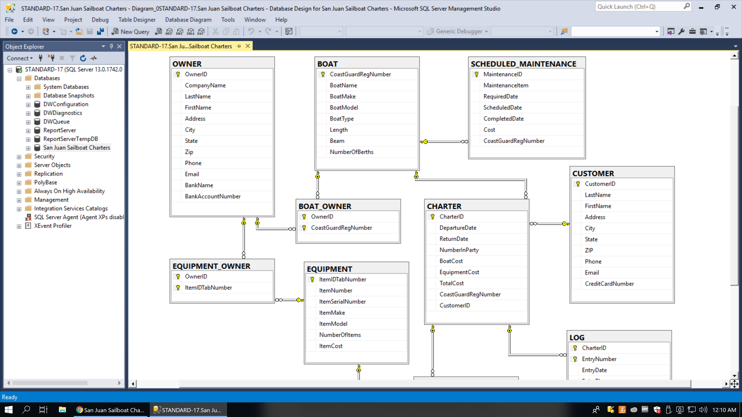

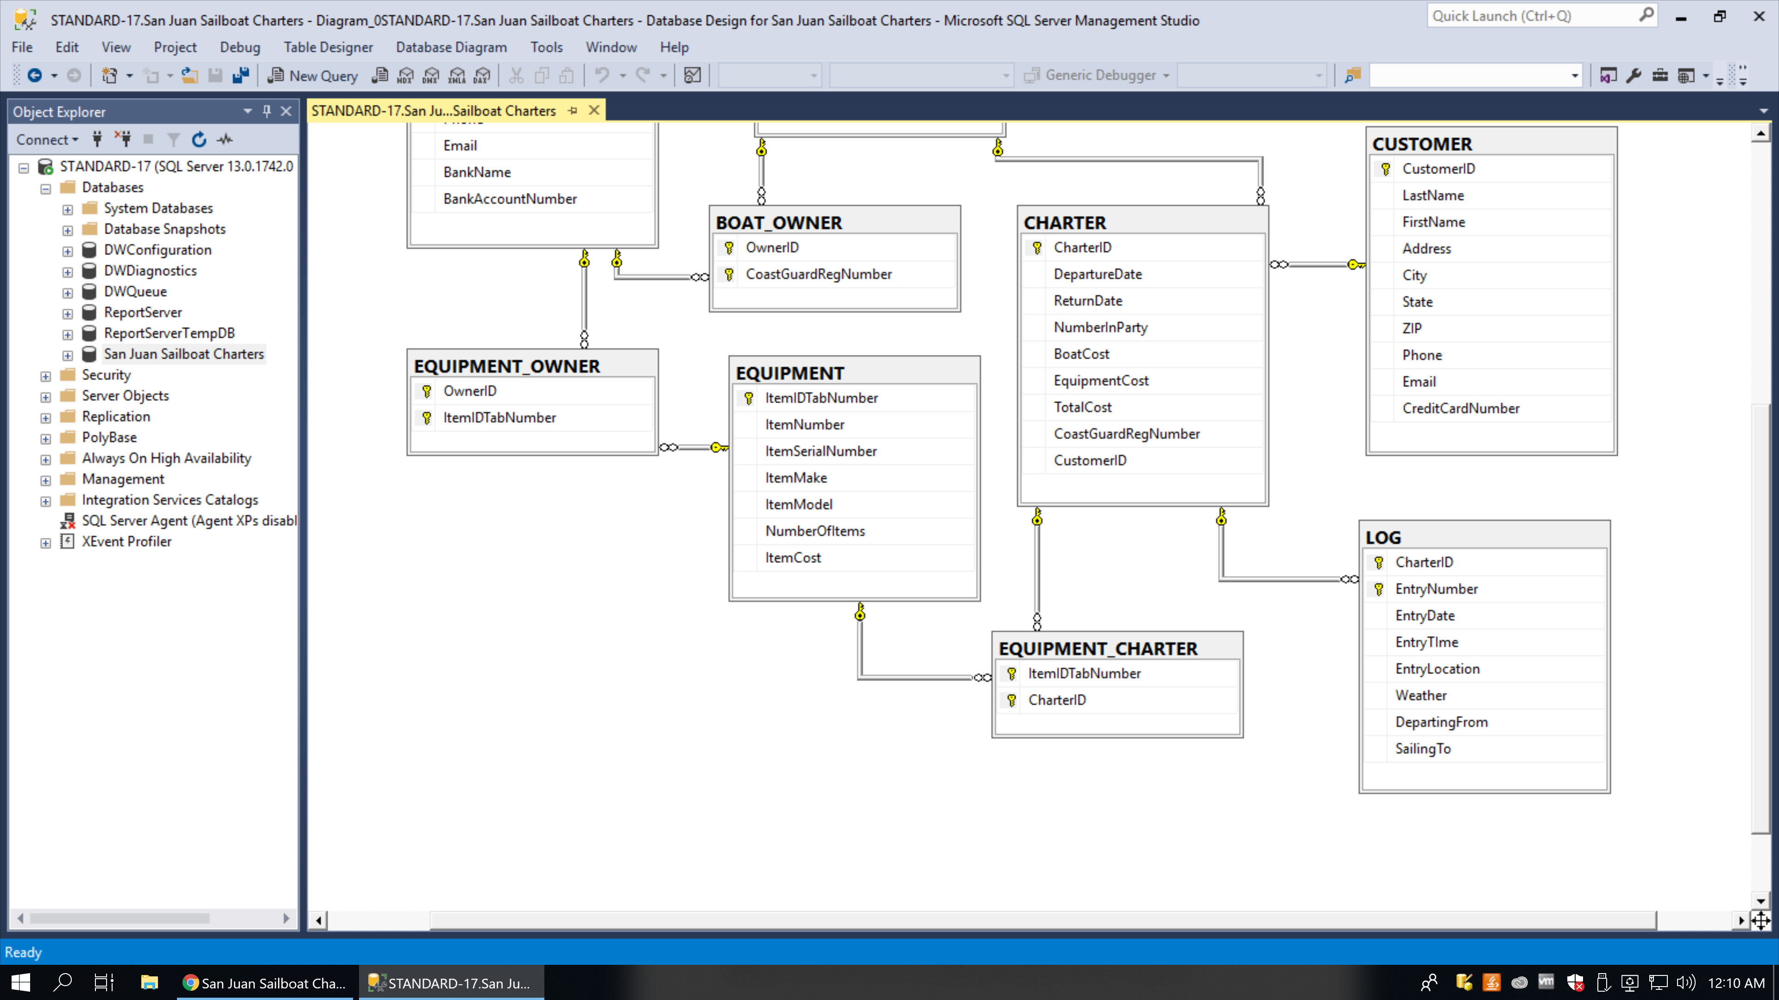

* ***TABLES***

OWNER

BOAT

SCHEDULED_MAINTENANCE

BOAT_OWNER

CHARTER

CUSTOMER

EQUIPMENT

EQUIPMENT_OWNER

EQUIPMENT_CHARTER

LOG.

* ***PRIMARY KEYS: -***

OwnerID for OWNER

CoastGuardregNumber for BOAT

OwnerID ad CoastGuardregNumber for BOAT_OWNER

MaintenanceID for SCHEDULED_MAINTENANCE

CharterID for CHARTER

CustomerID for CUSTOMER

ItemIDTabNumber for EQUIPMENT

ItemIDTabNumber and OwnerID for EQUIPMENT_OWNER

CharterID and ItemIDTabNumber for EQUIPMENT_CHARTER

CharterID and EntryNumber for LOG.

* ***FOREIGN KEYS: -***

No foreign keys in OWNER, BOAT, CUSTOMER and EQUIPMENT tables.

CoastGuardRegNumber for SCHEDULED_MAINTENANCE.

OwnerID and CoastGuardRegNumber for BOAT_OWNER.

OwnerID and ItemIDTabNumber for EQUIPMENT_OWNER.

CoastGuardRegNumber and CustomerID for CHARTER.

ItemIDTabNumber and CharterID for EQUIPMENT_CHARTER.

CharterID for LOG.

* ***COLUMN PROPERTIES: -***

1. **OWNER**table column properties

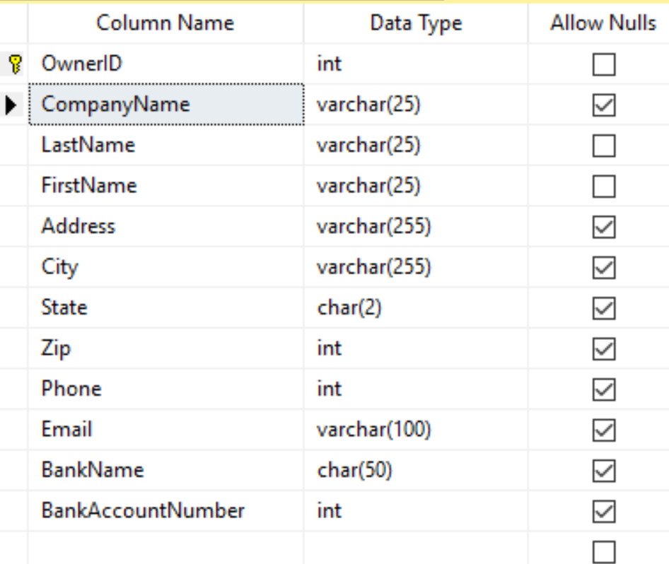

1. **BOAT** table column properties

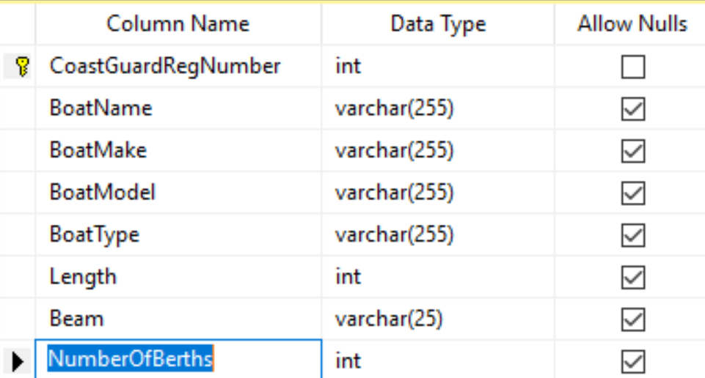

1. **BOAT_OWNER** table column properties

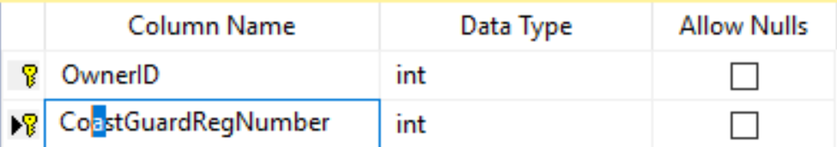

1. **SCHEDULED_MAINTENANCE** table column properties

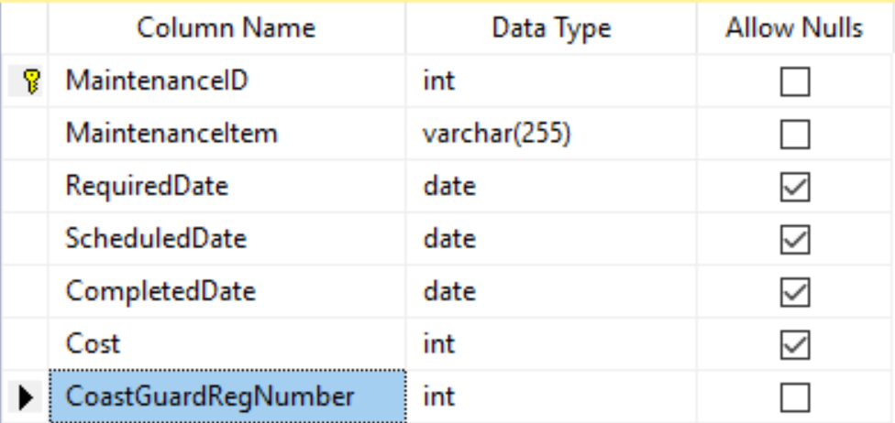

1. **EQUIPMENT** table column properties

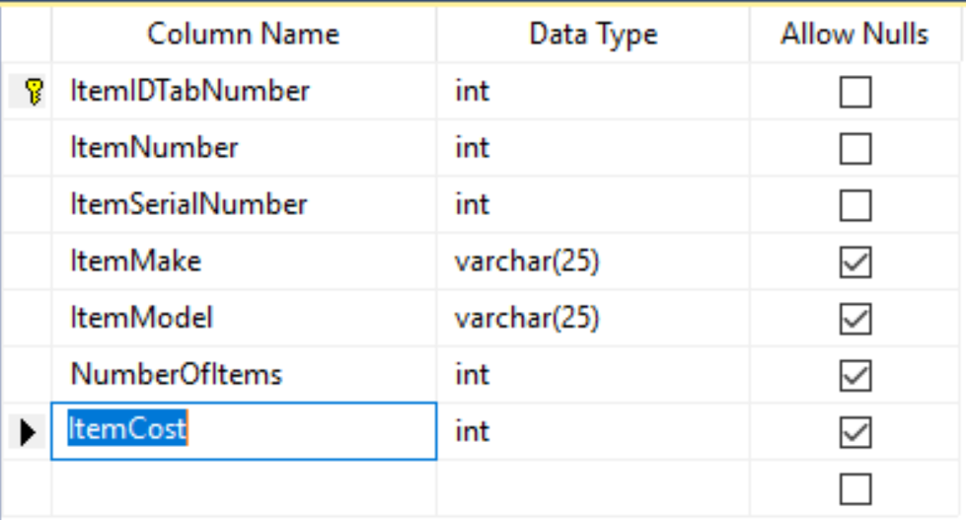

1. **EQUIPMENT_OWNER** table column properties

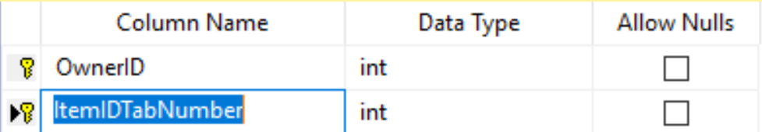

1. **CHARTER** table column properties

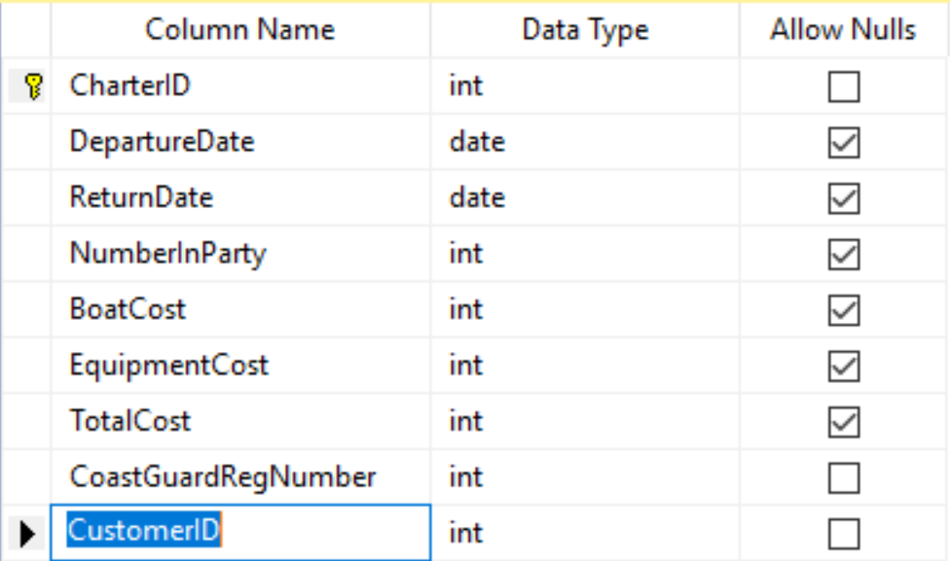

1. **EQUIPMENT_CHARTER** table column properties

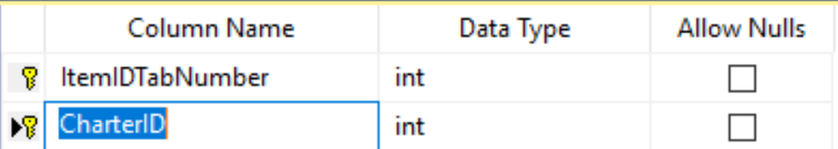

1. **CUSTOMER** table column properties

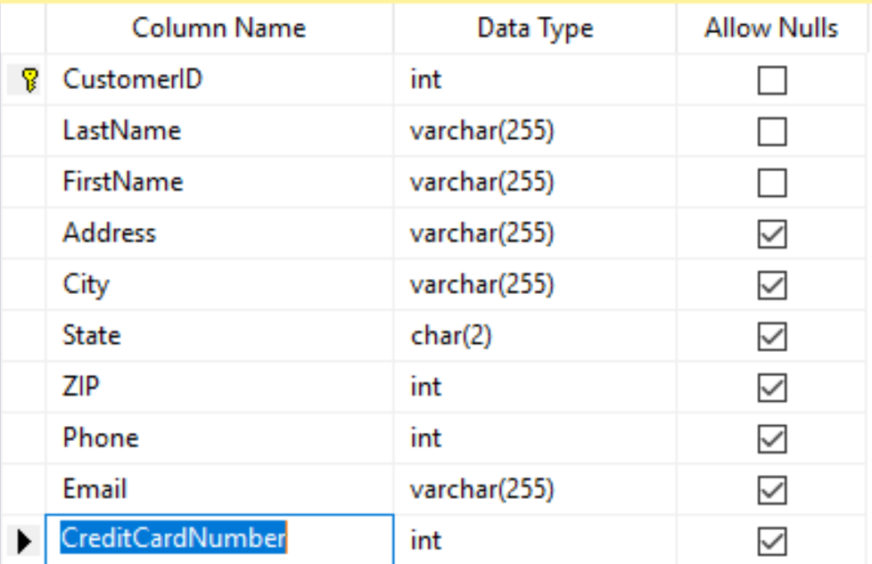

1. **LOG** table column properties

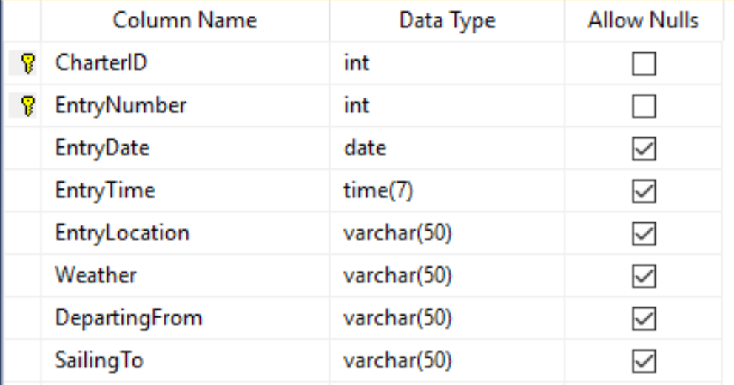

1. **WEAK ENTITIES REPRESENTATION**

The weak entities in my database design are BOAT_OWNER, EQUIPMENT_OWNER, EQUIPMENT_CHARTER, LOG and SCHEDULED_MAINTENANCE.

The entities BOAT_OWNER, EQUIPMENT_OWNER, EQUIPMENT_CHARTER and LOG are represented by adding the primary key of the parent table as the primary of these tables. All these entities are ID-Dependent entities in the database model. In Crow’s Foot E-R diagram their relationship with their parent is represented with solid lines.

The entity SCHEDULED_MAINTENANCE is also a weak entity and so is represented by adding the primary key of BOAT entity as foreign key of SCHEDULED_MAINTENANCE entity. The entity SCHEDULED_MAINTENANCE is weak because there can’t be maintenance if there is no boat.

This entity is NON-ID dependent because the primary key of BOAT is not the primary key of SCHEDULED_MAINTENANCE. Further, in Crow’s foot E-R diagram the relationship between BOAT and SCHEDULED_MAINTENANCE will be represented by dotted line.

1. **REPRESENTATION OF SUBTYPES AND SUPERTYPES ENTITIES**

In my database design there are no subtypes and supertypes and so are not represented.

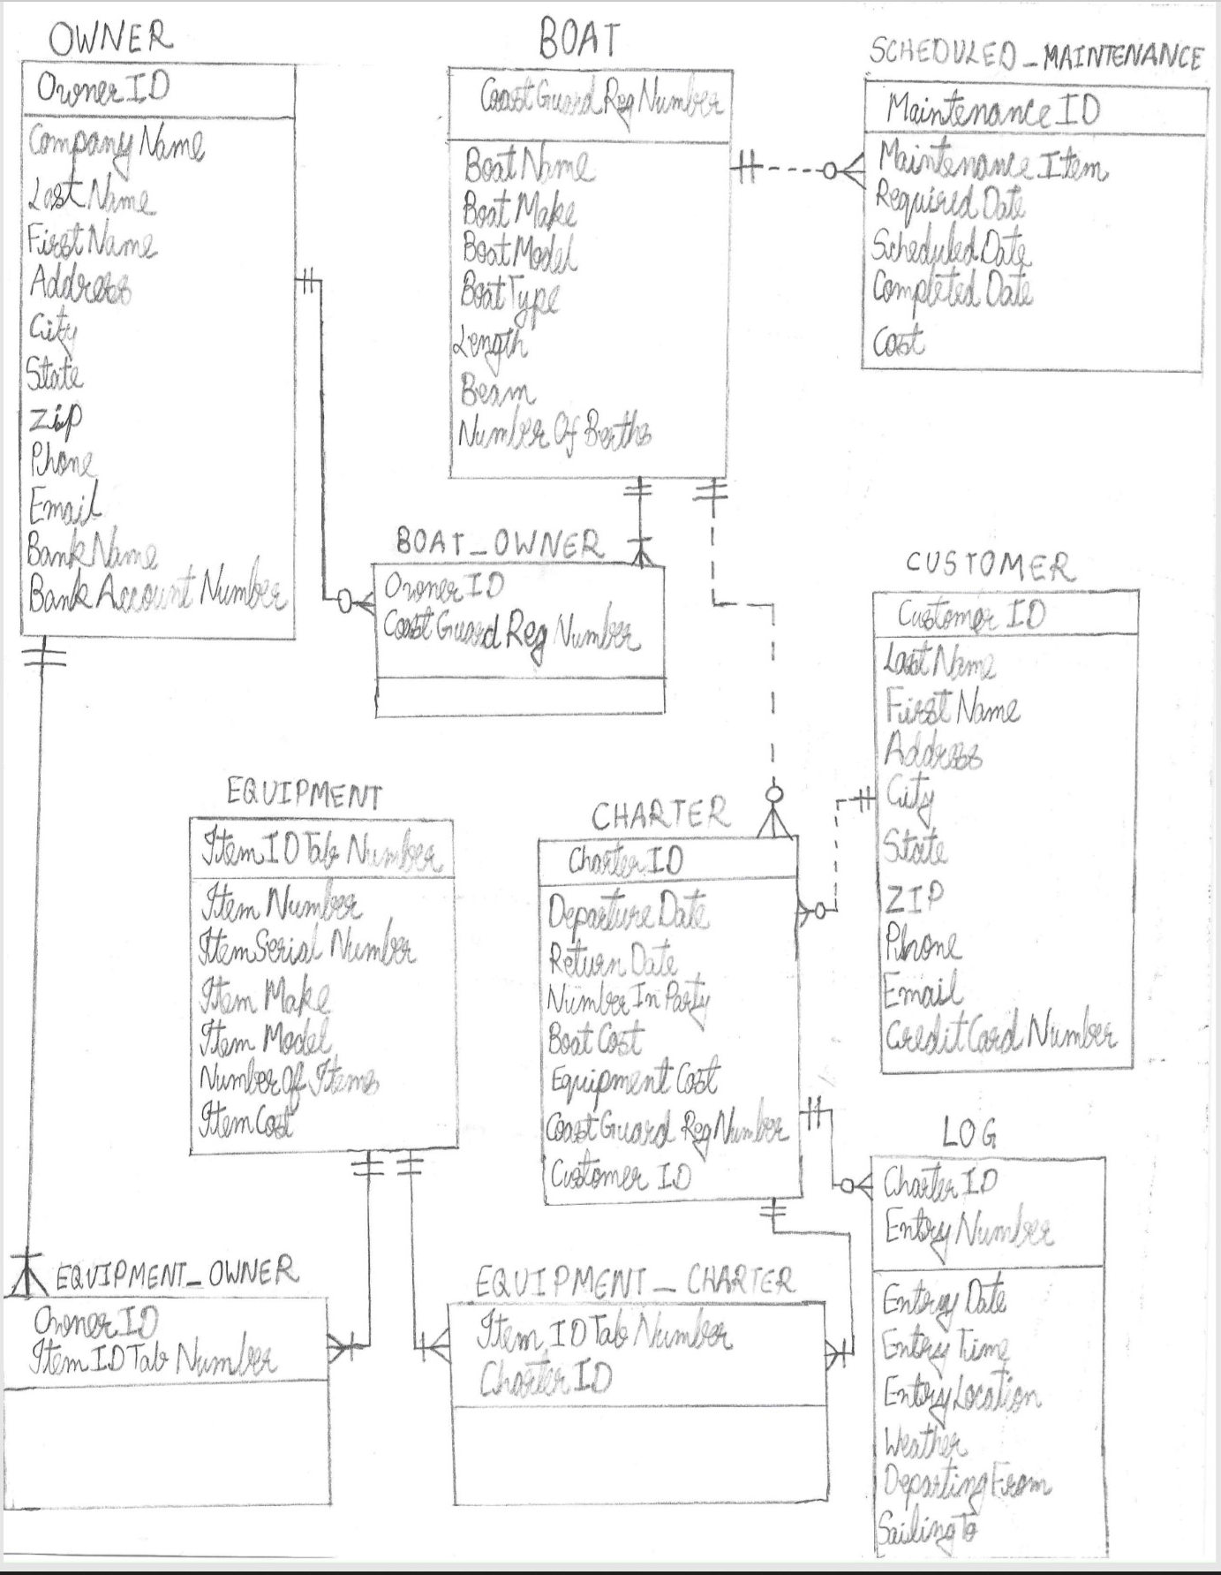

|  |  |  |
| --- | --- | --- |
| ***RELATIONSHIP*** | | ***REFERENTIAL INTEGRITY CONSTRAINT*** |
| ***PARENT*** | ***CHILD*** |  |
| OWNER | BOAT_OWNER | OwnerID in OWNER_BOAT table must exist in OWNER table |
| OWNER | EQUIPMENT_OWNER | OwnerID in EQUIPMENT_OWNER table must exist in OWNER table |
| BOAT | BOAT_OWNER | CoastGuardRegNumber in OWNER_BOAT table must exist in BOAT table |
| BOAT | SCHEDULED_MAINTENANCE | CoastGuardRegNumber in SCHEDULED_MAINTENANCE table must exist in BOAT table |
| BOAT | CHARTER | CoastGuardRegNumber in CHARTER table must exist in BOAT table |
| CUSTOMER | CHARTER | CustomerID in CHARTER table must exist in CUSTOMER table |
| CHARTER | LOG | CharterID in LOG table must exist in CHARTER table |
| EQUIPMENT | EQUIPMENT_CHARTER | ItemIDTabNumber in EQUIPMENT_CHARTER table must exist in EQUIPMENT table |
| CHARTER | EQUIPMENT_CHARTER | CharterID in EQUIPMENT_CHARTER table must exist in CHARTER table |
| EQUIPMENT | EQUIPMENT_OWNER | ItemIDTabNumber in EQUIPMENT_OWNER table must exist in EQUIPMENT table |